**DSAMS Jenkins configuration**

[**http://localhost:8080/**](http://localhost:8080/) **or http://localhost:8081/**

**Jenkins Global Tool Configuration**

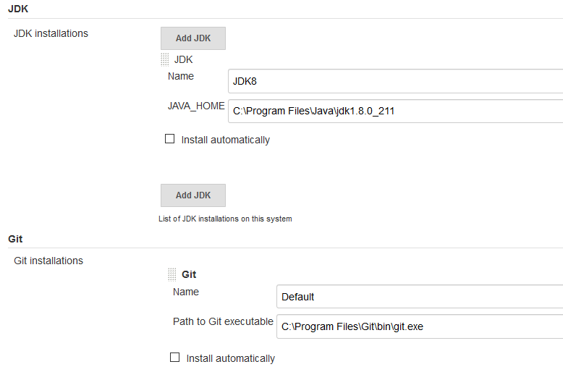

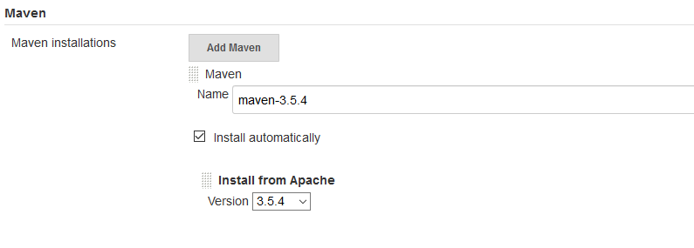

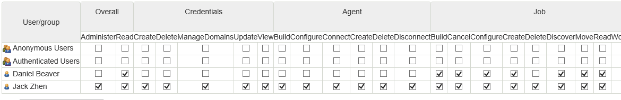

**DSAMS Job Setup**

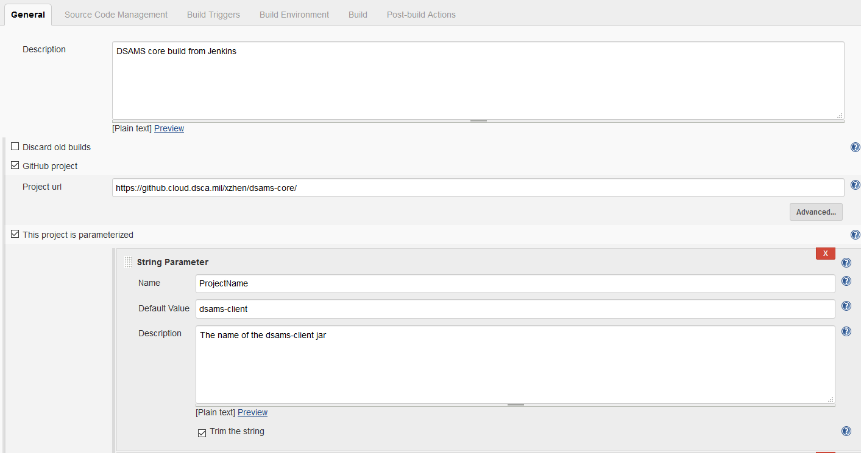

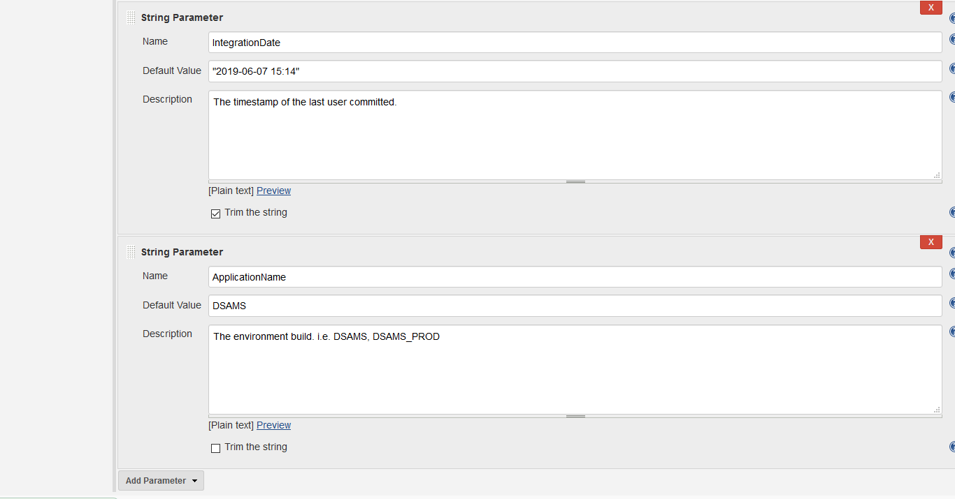

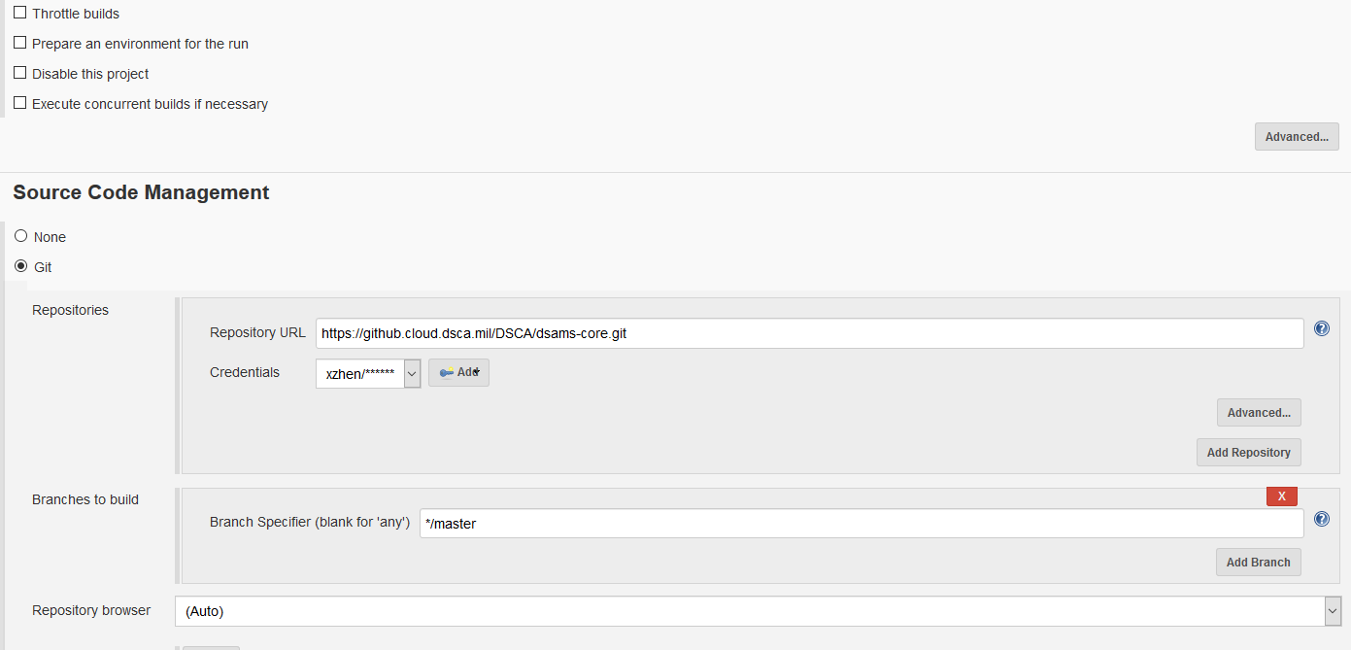

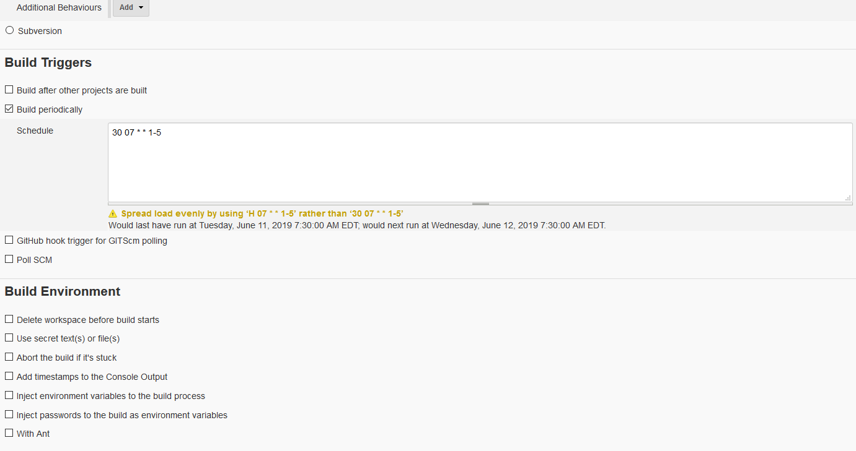

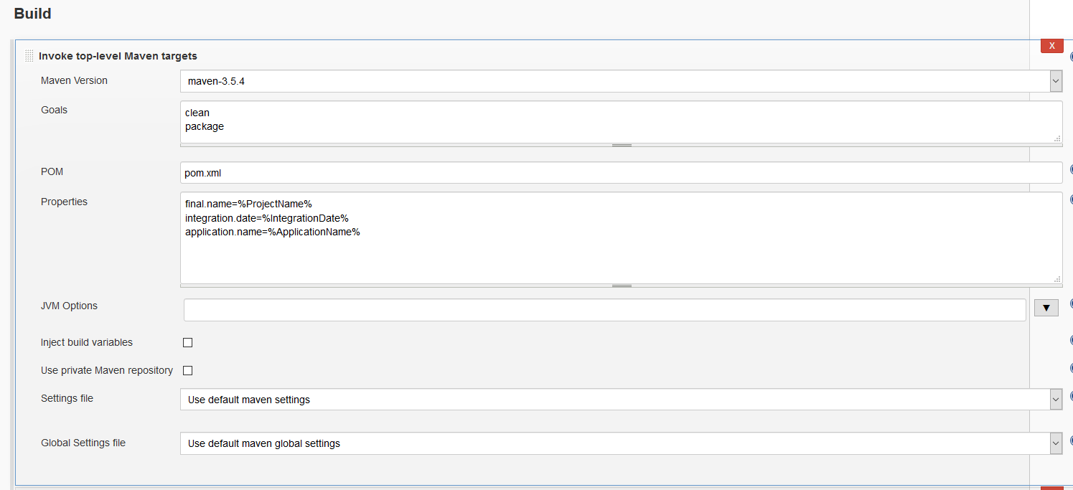

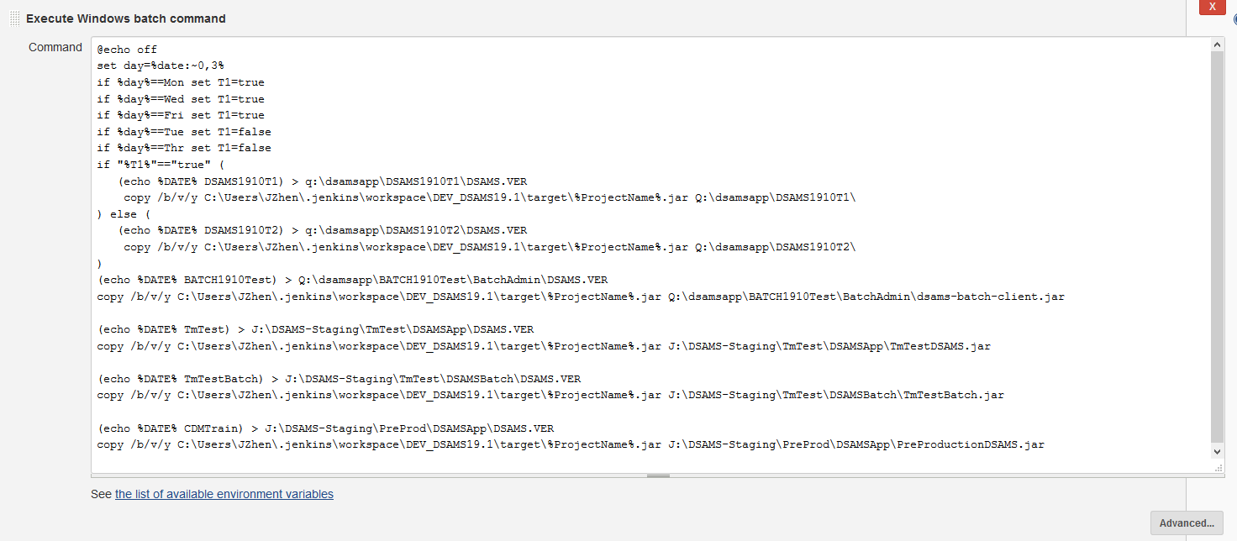

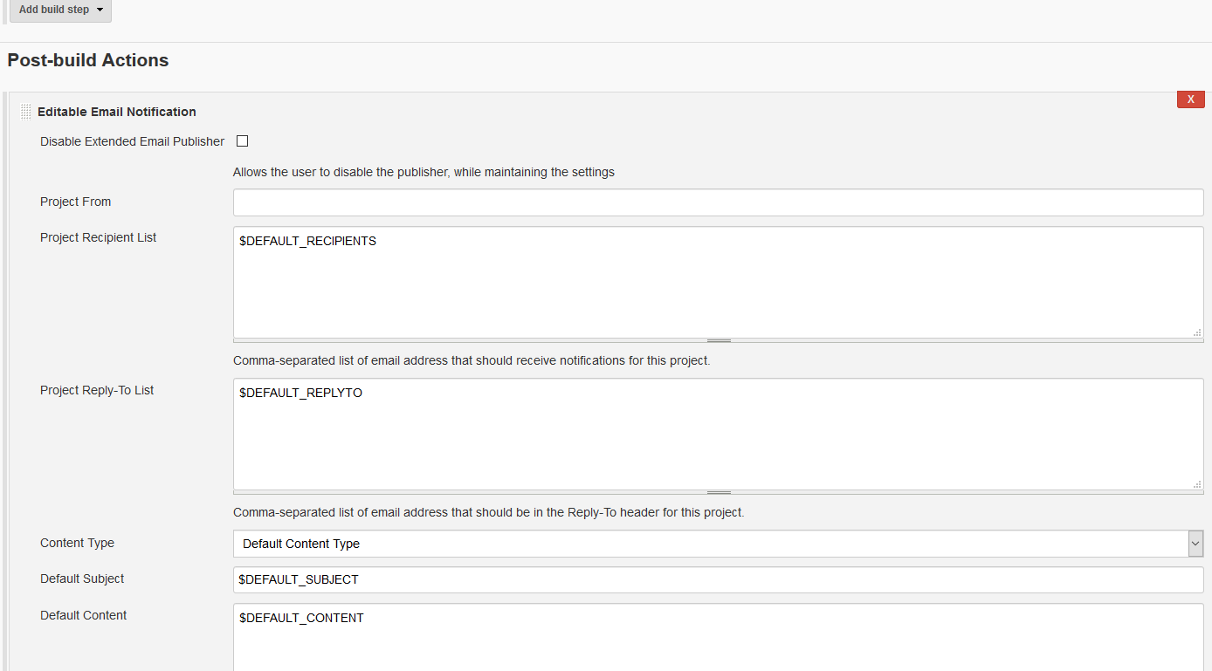

//DOS

final.name=%ProjectName%

integration.date=%IntegrationDate%

application.name=%ApplicationName%

==================================

//Linux

final.name=$ProjectName

integration.date=$IntegrationDate

application.name=$ApplicationName

DSAMS19.1

======================================

@echo off

set day=%date:~0,3%

if %day%==Mon set T1=true

if %day%==Wed set T1=true

if %day%==Fri set T1=true

if %day%==Tue set T1=false

if %day%==Thr set T1=false

if "%T1%"=="true" (

(echo %DATE% DSAMS1910T1) > q:\dsamsapp\DSAMS1910T1\DSAMS.VER

copy /b/v/y C:\Users\JZhen\.jenkins\workspace\DEV_DSAMS19.1\target\%ProjectName%.jar Q:\dsamsapp\DSAMS1910T1\

) else (

(echo %DATE% DSAMS1910T2) > q:\dsamsapp\DSAMS1910T2\DSAMS.VER

copy /b/v/y C:\Users\JZhen\.jenkins\workspace\DEV_DSAMS19.1\target\%ProjectName%.jar Q:\dsamsapp\DSAMS1910T2\

)

(echo %DATE% BATCH1910Test) > Q:\dsamsapp\BATCH1910Test\BatchAdmin\DSAMS.VER

copy /b/v/y C:\Users\JZhen\.jenkins\workspace\DEV_DSAMS19.1\target\%ProjectName%.jar Q:\dsamsapp\BATCH1910Test\BatchAdmin\dsams-batch-client.jar

(echo %DATE% TmTest) > J:\DSAMS-Staging\TmTest\DSAMSApp\DSAMS.VER

copy /b/v/y C:\Users\JZhen\.jenkins\workspace\DEV_DSAMS19.1\target\%ProjectName%.jar J:\DSAMS-Staging\TmTest\DSAMSApp\TmTestDSAMS.jar

(echo %DATE% TmTestBatch) > J:\DSAMS-Staging\TmTest\DSAMSBatch\DSAMS.VER

copy /b/v/y C:\Users\JZhen\.jenkins\workspace\DEV_DSAMS19.1\target\%ProjectName%.jar J:\DSAMS-Staging\TmTest\DSAMSBatch\TmTestBatch.jar

(echo %DATE% CDMTrain) > J:\DSAMS-Staging\PreProd\DSAMSApp\DSAMS.VER

copy /b/v/y C:\Users\JZhen\.jenkins\workspace\DEV_DSAMS19.1\target\%ProjectName%.jar J:\DSAMS-Staging\PreProd\DSAMSApp\PreProductionDSAMS.jar

DSAMS19.2

======================================

@echo off

set day=%date:~0,3%

if %day%==Mon set T1=true

if %day%==Wed set T1=true

if %day%==Fri set T1=true

if %day%==Tue set T1=false

if %day%==Thr set T1=false

if "%T1%"=="true" (

(echo %DATE% DSAMS1920T1) > q:\dsamsapp\DSAMS1920T1\DSAMS.VER

copy /b/v/y C:\Users\JZhen\.jenkins\workspace\DEV_DSAMS19.2\target\%ProjectName%.jar Q:\dsamsapp\DSAMS1920T1\

) else (

(echo %DATE% DSAMS1920T2) > q:\dsamsapp\DSAMS1920T2\DSAMS.VER

copy /b/v/y C:\Users\JZhen\.jenkins\workspace\DEV_DSAMS19.2\target\%ProjectName%.jar Q:\dsamsapp\DSAMS1920T2\

)

(echo %DATE% BATCH1920Test) > Q:\dsamsapp\BATCH1920Test\BatchAdmin\DSAMS.VER

copy /b/v/y C:\Users\JZhen\.jenkins\workspace\DEV_DSAMS19.2\target\%ProjectName%.jar Q:\dsamsapp\BATCH1920Test\BatchAdmin\dsams-batch-client.jar

(echo %DATE% KissBatch) > J:\DSAMS-Staging\Beta\DSAMSBatch\DSAMS.VER

copy /b/v/y C:\Users\JZhen\.jenkins\workspace\DEV_DSAMS19.2\target\%ProjectName%.jar J:\DSAMS-Staging\Beta\DSAMSBatch\BetaBatch.jar

(echo %DATE% Kiss) > J:\DSAMS-Staging\Beta\DSAMSApp\DSAMS.VER

copy /b/v/y C:\Users\JZhen\.jenkins\workspace\DEV_DSAMS19.2\target\%ProjectName%.jar J:\DSAMS-Staging\Beta\DSAMSApp\BetaDSAMS.jar

DSAMS_PROD

======================================

@echo off

(echo %DATE% PROD-DSAMS19.1) > J:\DSAMS-Staging\PROD\DSAMSApp\DSAMS.VER

copy /b/v/y C:\Users\JZhen\.jenkins\workspace\PROD_DSAMS\target\%ProjectName%.jar J:\DSAMS-Staging\PROD\DSAMSApp\

(echo %DATE% DSAMS19.1Batch) > J:\DSAMS-Staging\PROD\DSAMSBatch\DSAMS.VER

copy /b/v/y C:\Users\JZhen\.jenkins\workspace\PROD_DSAMS\target\%ProjectName%.jar J:\DSAMS-Staging\PROD\DSAMSBatch\DSAMSBatch.jar

**Maven:**

**cd C:\Users\JZhen\.m2**

mvn -U clean package -Dintegration.date="2019-05-09 09:46" -Dapplication.name="DSAMS_PROD

Sandbox Jenkins Configuration

